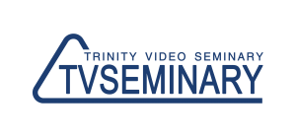 | http://www.tvseminary.org  tvs.student@gmail.com  +79202609999

Requirements for the program «SPECIALIZATION IN MINISTRY: CHURCH HISTORY»
(for students accepted before 2015)

Subjects | Professor | Credits
HS 202 Church Fathers | Marina Karetnikova | 5
HS 203 Reformation | Marina Karetnikova | 5
HS 201 New Testament History | Mel Loucks | 5
HS 204 History of Evangelical Movement in Russia | Vladimir Popov | 4
HS 205 History of Early Evangelical Movements | Marina Karetnikova | 4
TOTAL NUMBER OF CREDITS: 23

(in yellow are the courses which are required for the Bachelor in Christian Ministry degree)

