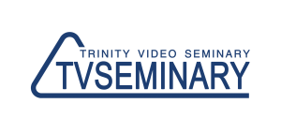 | http://www.tvseminary.org  tvs.student@gmail.com  +79202609999

Requirements for the program «SPECIALIZATION IN MINISTRY:
BIBLICAL COUNSELING / CHRISTIAN LIFE »
(for students accepted before 2015)

Subjects | Professor | Credits
PT715 Christian Ethics | John Feinberg | 6
РТ205 Marriage and Family 1 | Telepovs | 3
РТ206 Marriage and Family 2 | Telepovs | 3
РТ207 Dependency as Family Crisis | Telepovs | 4
РТ208 Pastoral Counseling | Telepovs | 4
РТ 217 Gerontology | Marina Karetnikova | 5
РТ 219 Theology of Rest | Jim Anderson | 4
PT 532 Spiritual formation | Dennis Kizziar | 3
РT 512 Cross-cultural communication | Duane Elmer | 5
TOTAL NUMBER OF CREDITS: 37

(in yellow are the courses which are required for the Bachelor in Christian Ministry degree)

